1. **HTML and CSS for Baby Sloth Page:** To create the expected page output, you can use the following HTML and CSS code:

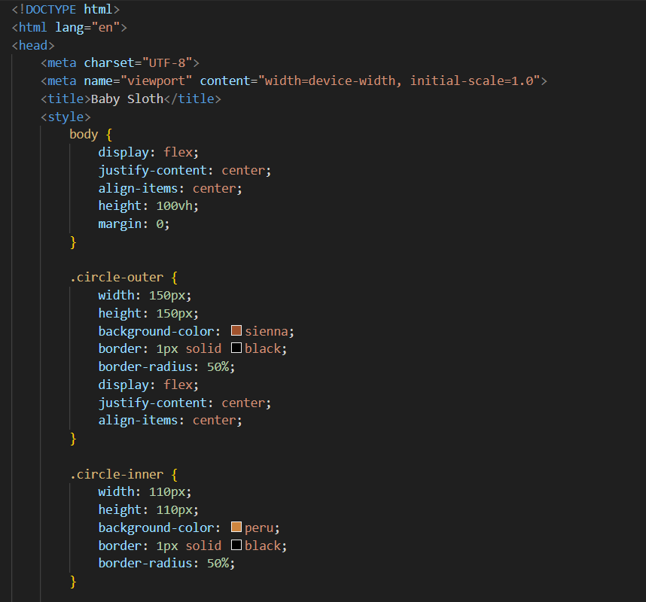

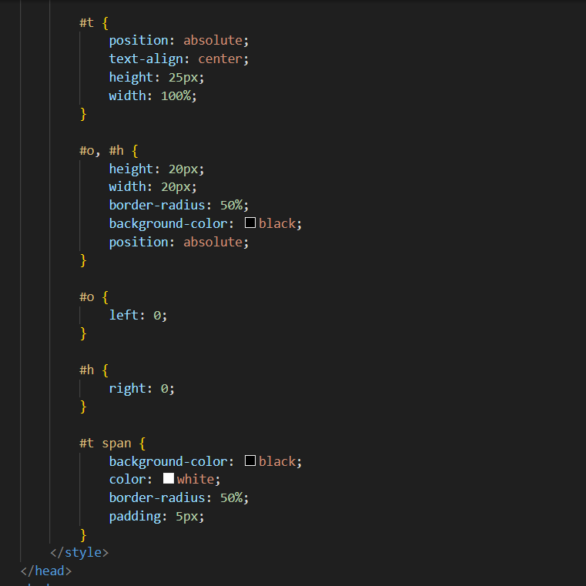

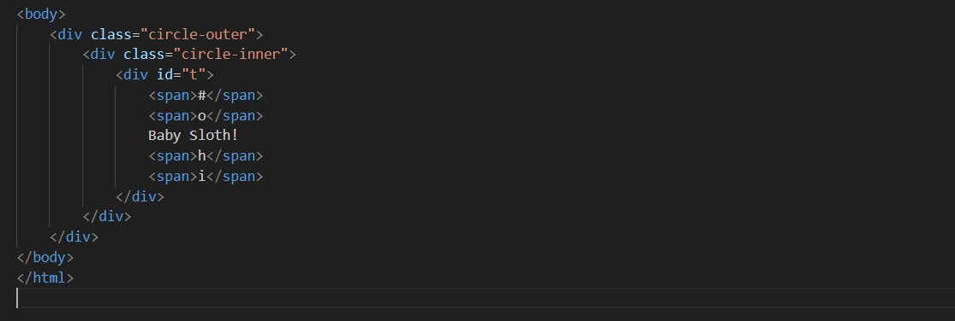

1. **HTML and CSS for "CSS Short & Sweet" Header:** For this part, you can use the following HTML and CSS code:

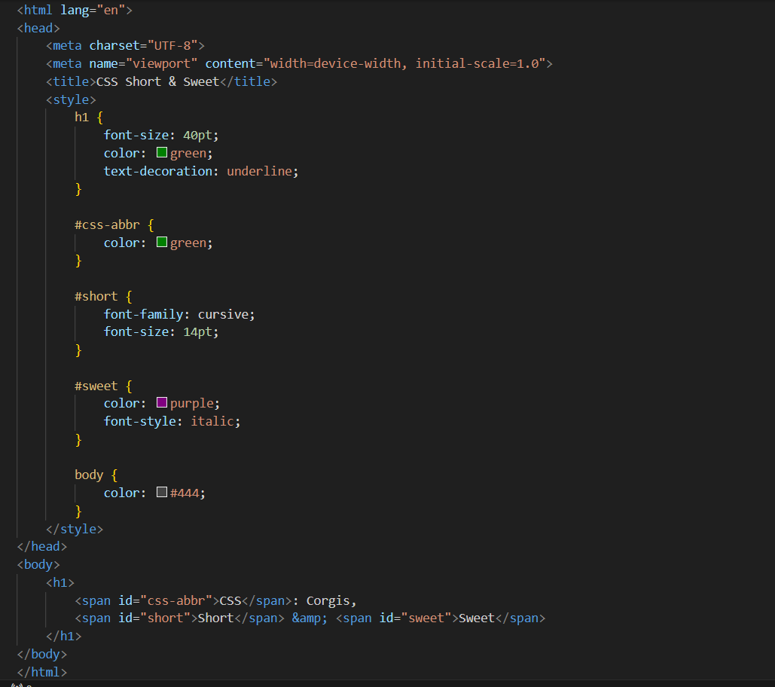

1. **JavaScript Functions:** Here are JavaScript functions for the tasks you mentioned:

